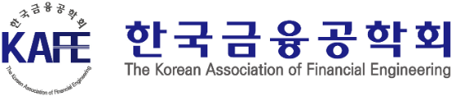
2025 APAF International Conference
Call for Papers and Participants

On July 16 (Wed), the Korean Association of Financial Engineering (KAFE) will host an international conference on finance, finance engineering and economics in Busan International Finance Center (BIFC), Busan, Korea. This conference will be held in collaboration with our long-standing partners, the Japanese Association of Financial Econometrics and Engineering (JAFEE), Korea-America Finance Association (KAFA), and Financial Engineering Association of Taiwan (FeAT).

Date and Location
July 16 (Wed), 2025; Busan International Finance Center (BIFC), Busan, Korea

Paper Submission and Registration
All submissions should be sent by email to Seongju Moon (kafe.apaf@gmail.com). Paper Title and Author Details (see Conference Registration Form) should be submitted by May 30. Complete papers or (1-page) abstracts with full author details should be submitted by June 13. Submit your presentation materials(PPT/pdf file) by July 4.

Topics
All topics in the fields of finance, finance engineering and economics can be presented. Research of contemporary trends in the digital economy and finance, as well as interdisciplinary studies, are welcomed. Suggested topics include:
•AI and Financial Economics: Algorithmic Trading; Big Data; Chat GPT; Machine Learning
•Asset Management (AM): Automated AM; Outsourced Chief Investment Officer (OCIO); Pension Funds
•Carbon and ESG: Corporate Governance; Energy & Environment; Gender Issues; Green Finance; Sustainable Finance
•Digital Finance and Economy: Bitcoin; CBDC; Cryptocurrency; Digital Currency Exchanges; STO
•Finance and Financial Math: Corporate finance, Investment, Financial Mathematics
•Financial Engineering: Financial Derivatives; High-Frequency Trading; Interdisciplinary Finance
•Recent Trends in Economic Research: Applied Economics; Computational Economics; Micro/Macroeconomics

Conference Registration Form (send it to kafe.apaf@gmail.com)
 | Name | Nationality | Affiliation | Position | E-mail
Presenting Author
Co-Author 1
Co-Author 2
Paper Title

Hoon Cho, President of the Korean Association of Financial Engineering

